**PROJECT 4 AWS ADVANCE -LU**

**GIT PROJECT:**

Task1: create a repository in github

● Git init

Git init is a command that is used to initialize a repository

● Both config commands

Commands to use are; git config –global user.email <email address>

And git config –global user.name <github name>

Screenshot for git init

Task2: open git bash and clone contents from remote repository

● clone

To clone use git clone < url for the repository>

● show the folder in local repository

Sreenshot for the folder in the local repository:

Task3: create a file in the local space and push it to the remote repository

To create a file use command touch <filename>

● add

Command to use is git add <file name>

Screenshot for the add command;

● commit

Use git commit -m “first” <file name>

ScreenShot for git commit:

● push successful

Command to use is git push -u origin main

Screenshot for successful push:

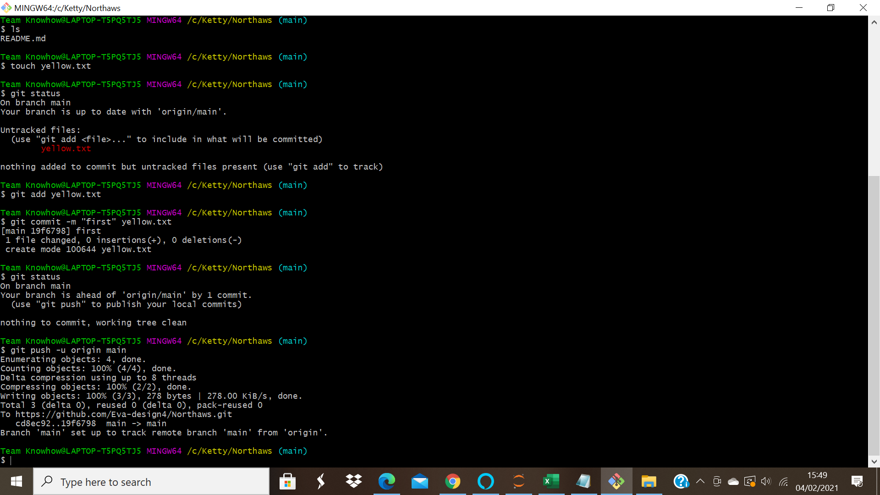

● show the file in remote repository

Screenshot for the file in remote repository:

Task4: Branching and merging

Execute all commands and add screenshots.

Git branching:

● git branch

Git branch list the available branches

Screenshot for git branch:

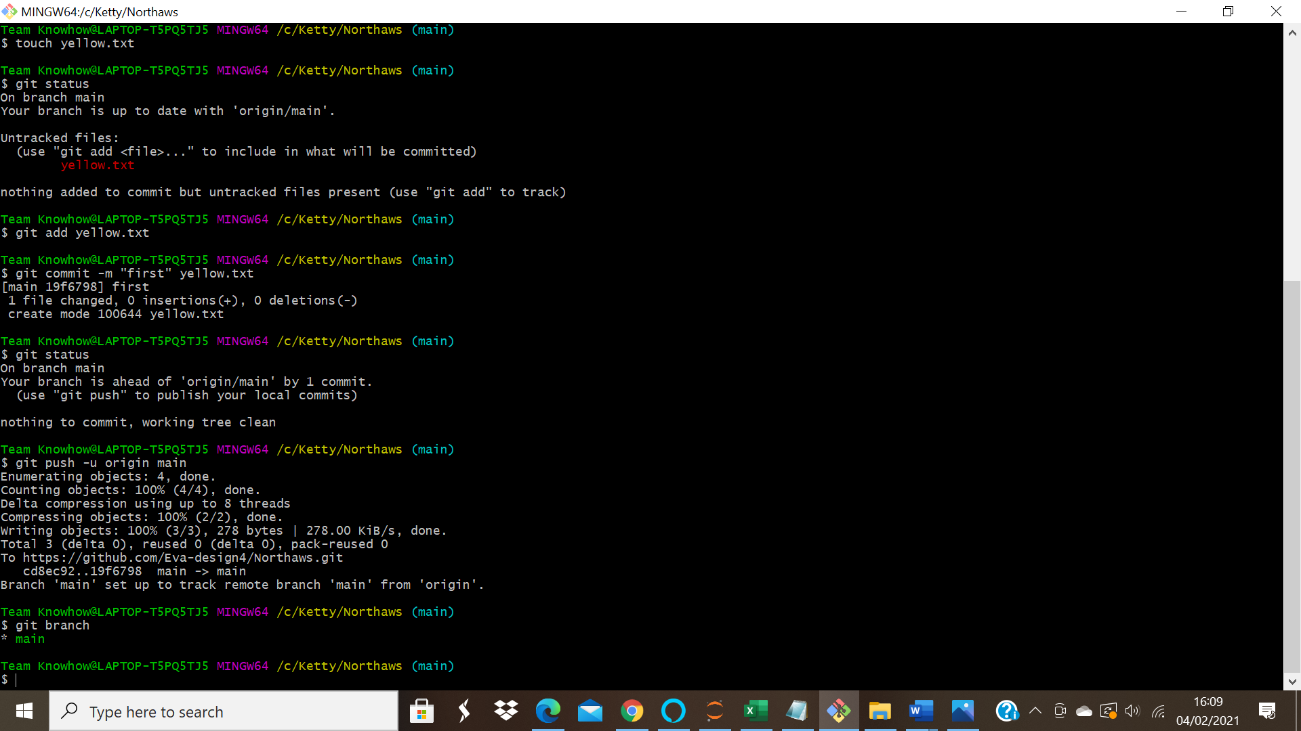

● git branch branch name

This command creates a new branch

● git checkout branchname

Git checkout is for moving to a particular branch

Screenshot for the newly created branch; and checkout command

● git merge branchname

This command is used to merge contents of branches into main branch

Screenshot for merge command;

● git branch -d branchname

This command is for deleting the branch.

Screenshot of the executed command:

● git branch -D branchname

This is to force delete a branch

Screenshot;

● git checkout -b branchname

This creates a new branch and moves directly into it.

Screenshot for the newly created and switched into branch;

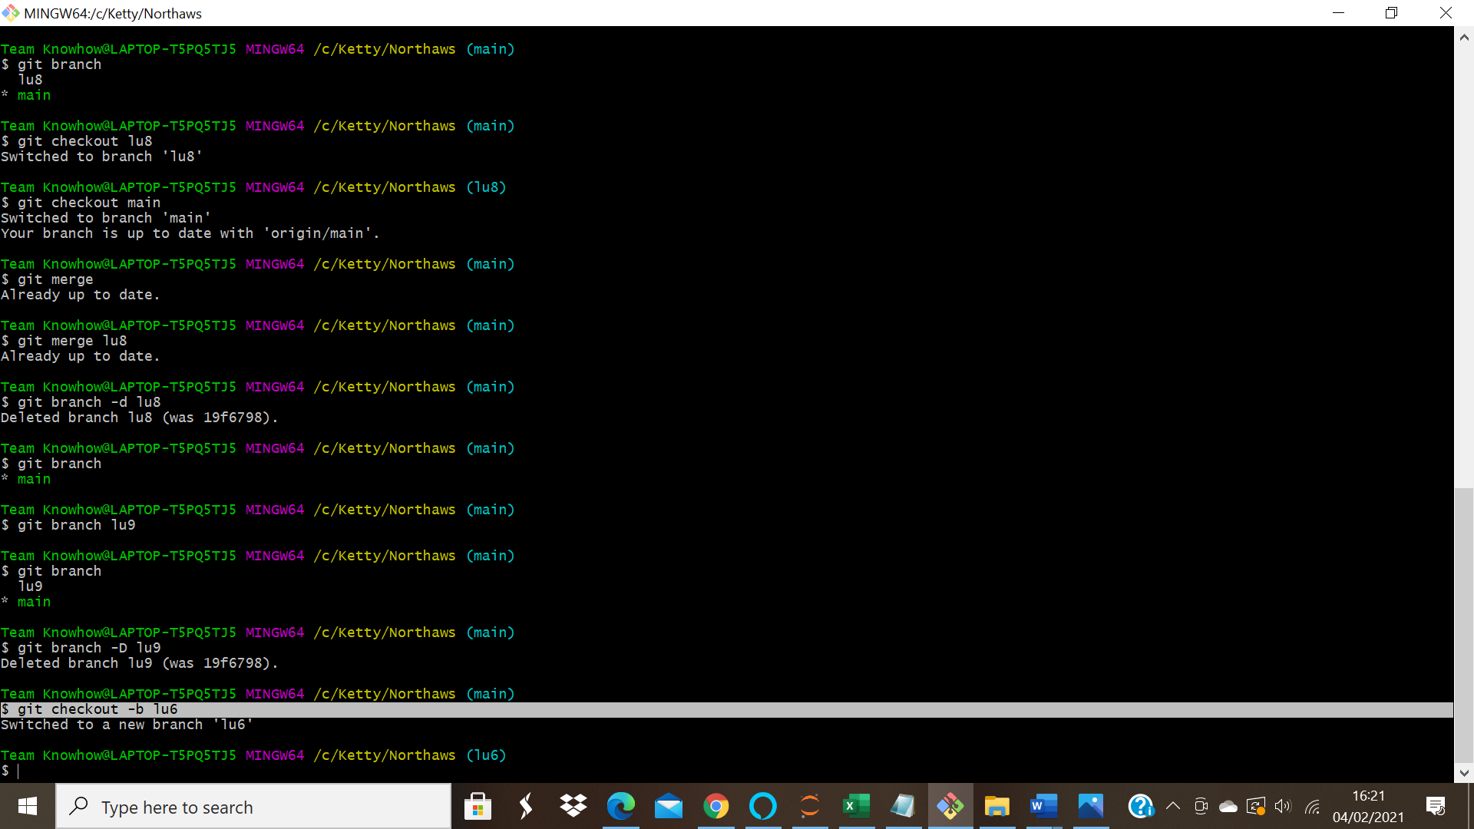

● git log

This gives the contents of the changes you have made.

